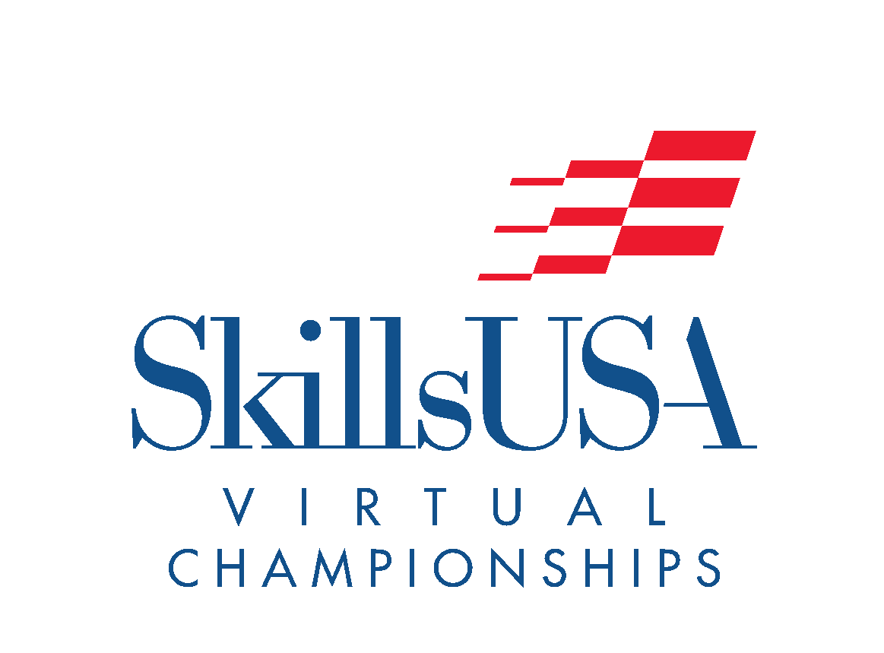 | Pin Design  (PD)  A/V Technology & Communication  Leadership Development Contest  Virtual Championships Information

National Contest: Yes Participation: Individual

Contest Description
Students present their pin artwork and participate in an oral presentation regarding all aspects of the creation of their design. Competitors will explain how the pin represents the state, its unique qualities and why another SkillsUSA student or adult member would want to wear it.

Submission Guideline
Members will submit their design in a PDF format and a recorded video of their presentation. These submissions should follow the guidelines outlined within the current National Technical Standard.

How to Submit
Files will need to be uploaded to link by the submission deadline. No late submissions will be accepted. Save files as “school name_contest name”.

The submission deadline is Tuesday, January 31st.

