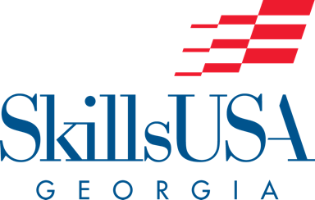

2020 SkillsUSA Georgia
TIEGA Pre-Conference Agenda

9:30 - 10:30 New/Beginner Advisor Training
Amanda McClure
This session is for new/beginning SkillsUSA advisors or those who want a refresher on chapter management. Topics to be discussed include: chapter organization, recruitment ideas, the SkillsUSA POW, budget, as well as training and using officers.

9:30 - 10:30 Advanced Advisor Training
Debbie Peabody
Session topics include CEP 2.0 updates, officer training and SkillsUSA week activities. Advisors should come ready to share with colleagues and discuss successful activities their chapters have planned and/or completed.

10:30 - 11:30 Contest Information
Debbie Peabody
Are you up to date on all competitions? Do your chapter’s members compete in leadership, occupationally related and Georgia only competitions? Do you have questions about registering? Finding updates? Locating technical standards for national and Georgia competitions? Get answers to these and any other questions you have.

10:30 - 11:30 Technology Hacks for SkillsUSA*
Amanda McClure
Develop skills you and your officers can use for chapter business. Discover how to use Google docs, Google forms, Google Classroom and QR codes to help with chapter management and organization. You will have the opportunity to create a resource for your chapter to use and receive help during this session.

11:30 - 1:00 Lunch

1:00 - 1:30 Framework Information and Activities
Debbie Peabody
SkillsUSA has created several unique resources to assist advisors as they incorporate the SkillsUSA Framework into both classroom and chapter meetings/activities. Experience and review these resources with your peers as we prepare to write mini lessons for you to use in the following session.

1:30 - 2:30 Framework Mini Lessons*
Debbie Peabody
All CTAE course standards include Standard One: Demonstrate employability skills required by business and industry. The last standard for all courses is: Examine how SkillsUSA is a co-curricular part of career and technical education industry. How can SkillsUSA resources be used as you teach these two standards? Advisors will work together to write mini framework lessons to be shared on the SkillsUSA Georgia website.

2:30 - 3:30 Fundraising: More Money, More Problems…Not in SkillUSA!
Lynsey Singleton
Are you looking for new, fun, and innovative ways to raise money for your chapter? What about free money through grant-writing? Learn about fundraising opportunities and how to tie it to projects and every day financial skills students need.

