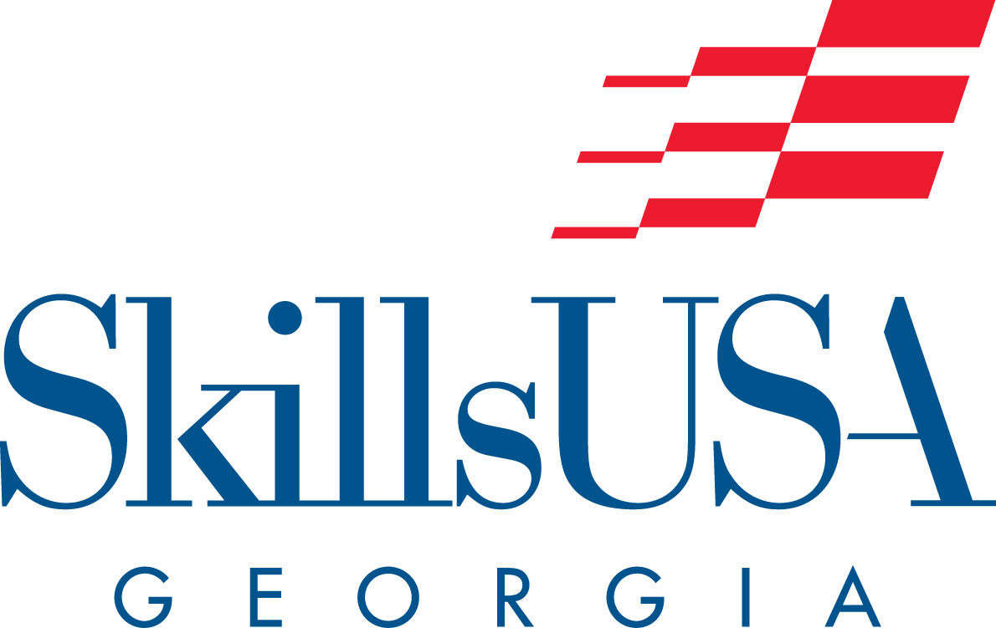

Region 7 Championships Registration Packet (2021-2022)
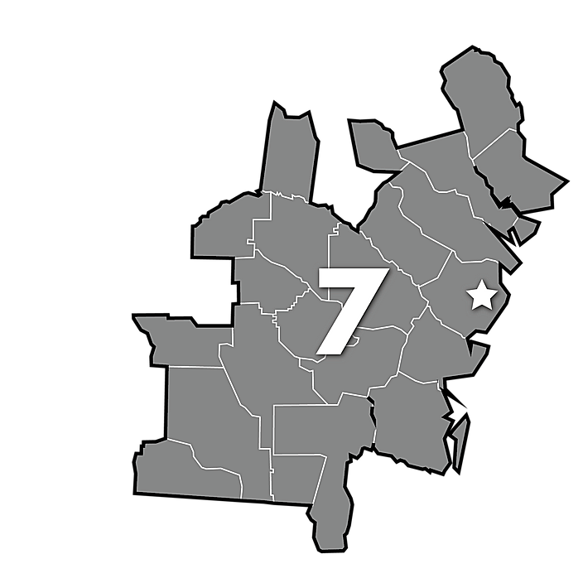

Welcome to the 2021 Region 7 Championships!

Championships Date
January 14, 2022

Location
Golden Isles Career Academy

Region Chairperson Contact:
Roy McDowell
Golden Isles Career Academy
rmcdowell@glynn.k12.ga.us

Registration and Fees
Region 7 Registration Deadline:
December 17, 2021

Registration Payment Deadline:
January 7, 2022

Online Region Testing: If Needed
Thursday, January 6, 2022

Overview of Fees:
*Fee includes t-shirt
Contestants | $20.00
Observers | $20.00
Advisors | $50.00

Lunch
Lunch is being served on site.
Lunch is included in your registration. If you choose not to eat lunch at GICCA the price will be the same.

Make Checks Payable to: SkillsUSA Georgia

Mail to:
SkillsUSA Georgia
1740 Hudson Bridge Road
Suite 1052
Stockbridge, GA 30281

Tentative Agenda for Region 7 Championships

When You Arrive
- Please first come to the Registration Desk (Main lobby).
- There will not be a formal meeting before contests. Meetings will be at your contest location.

Registration Desk
- Changes in student names for Region Championship
- Pick-up packets (one advisor per school)
- Student name tags
- Registration receipts
- Maps
- Agenda
- Miscellaneous

Agenda
7:30 - 8:30 AM | WHAT: Registration/Check-in/Judges meeting.  WHERE: GICCA Front Lobby
8:30 - 9:00 AM | Orientation in GICCA Conference Room
9:00 AM - 12:00 PM | Championships begins
12:00 PM - 1:30 PM | Lunch
1:30 PM | Awards Ceremony

Region Championship Regulations

Student Eligibility
- Students must be registered for a region contest by the deadline set by the chairperson. If a substitution for a team member is made, please notify the region registration table on the date of the competition.
- Each student must be a paid SkillsUSA member and entered on SkillsUSA Register prior to Region Championships. A copy of the chapter Membership Roster should be attached to the Eligibility Verification Form.
- Each student must be eligible for competition within the guidelines set forth in the 2021-2022 SkillsUSA Championships Technical Standards.
- Advisors must submit a signed Eligibility Verification Form (one per school) verifying their contestant’s eligibility.
- If a student competes in the Region Championships and is discovered later to be ineligible, the student’s score will be nullified, and awards given and eligibility for the State Leadership and Skills Conference will be revoked.

Implementation of Region Championships
- The deadline for registration will be established by the Region Chairperson and the deadline will be published in materials. All advisors are expected to abide by the established deadlines.
- Each region will offer all the contests included on the Region Contest List. Region Chairpersons will determine by registration numbers if a contest has enough entries to conduct.
- First and Second place region winners advance to the State Leadership and Skills Conference. If a region chooses to hold a competition in a state only contest, it may do so. Eligibility for the State Leadership and Skills Conference in that contest is not determined by region results, since state only contests are open to one student from any school.

Region Championships Contests
- First and Second place region winners will advance to the State Leadership and Skills Conference. The EXCEPTION includes:
  - TeamWorks top ten teams from across the state.
  - Welding Fabrication top eight teams from across the state.
  - Broadcast New Production top 16 teams from across the state.
- The top first, second and third place teams will not be announced for TeamWorks, Welding Fabrication and Broadcast News during the Region Championships Awards Ceremony. SkillsUSA Georgia will make an announcement if there is a top winner in your region. SkillsUSA Georgia is not releasing scores for these contests. SkillsUSA Georgia will only let you know if you have a placement.
- Welding Fabrication
  - Each team will be required to register each member in their team, with one student being an alternate. The alternate team member will take the same test as the other team members that is composed of Core questions along with questions representative of Welding Fabrication. Each team must register an alternate to participate. If the team should lose a member, then the alternate would be in place to compete at the state level. Replacement of a team member should only be done in case of an emergency and must be approved by the SkillsUSA Georgia Executive Director.
- TeamWorks
  - Each team will be required to register each member of their team, with one student being an alternate. Each team must register an alternate, however the alternate will not be charged a registration fee. The alternate will not test. The alternate must also communicate with Ashley Brown (SkillsUSA Georgia Executive Director) their name and school via email. Please email Mrs. Brown at abrown@skillsusageorgia.org. Replacement of a team member should only be done in the case of an emergency and must be approved by the Executive Director.
- Contests will be set up to fall within the parameters of the scope of the contest as listed in the SkillsUSA Championships Technical Standards.
- Official SkillsUSA Dress or Business Dress for Leadership Competition is required. For other contests, SkillsUSA Dress IS REQUIRED at Region Championships. This information can be found in the Technical Standards.
- Equipment/Tools needed for each contest are listed in the Technical Standards. If the tool list for your region is different, the Region Chairperson will inform each advisor in their region.
- A Grievance Committee of at least 3 people will be in place to handle any protest that might develop.
- Resumes
  - Every contestant will be expected to present a typed 1-page resume to the Contest Chair of their contest. Resume tips are included at the end of this packet.
  - Resumes for team events - one member of the team will be responsible for presenting the Contest Chair of their contest with each team member’s resume.
  - Failure to provide the resume as instructed will result in a deduction from the overall final score of the individual contestant’s score or team score.

Region Contest List
Contest Name | Type of Event
Advertising Design | Skilled & Technical Sciences
Architectural Drafting | Skilled & Technical Sciences
Automotive Service Technology | Skilled & Technical Sciences
Broadcast News Production  *Online testing | Skilled & Technical Sciences
Cabinetmaking | Skilled & Technical Sciences
Carpentry | Skilled & Technical Sciences
Cosmetology | Skilled & Technical Sciences
Electrical Construction Wiring | Skilled & Technical Sciences
Esthetics | Skilled & Technical Sciences
Extemporaneous Speaking | Leadership Development
First Aid-CPR | Occupationally Related
Graphic Communications | Skilled & Technical Sciences
Job Interview | Leadership Development
Job Skill Demonstration A | Leadership Development
Job Skill Demonstration Open | Leadership Development
Masonry | Skilled & Technical Sciences
Pin Design | Leadership Development
Plumbing | Skilled & Technical Sciences
Prepared Speech | Leadership Development
Quiz Bowl | Leadership Development
T-Shirt Design | Leadership Development
TeamWorks  *Online testing | Skilled & Technical Sciences
Technical Drafting | Skilled & Technical Sciences
Welding | Skilled & Technical Sciences
Welding Fabrication  *Online testing | Skilled & Technical Sciences

PLEASE REVIEW
If you are a participant in the below contests:

Broadcast News Production
TeamWorks
Welding Fabrication

*All other Region 7contests will take place before online testing. Online contest winners will be announced via email and medallions will be mailed to recipients. Any online contestant changes must take place after December 29th, 2021. Contestants that competed in another Region 7 contest will not be allowed.

SkillsUSA Georgia Online Testing

General Information
Online testing will be Thursday, January 6, 2022
Testing will begin at 8AM on January 6 and end at 8PM.
Deadline to register students for this event is December 17, 2021 (via SkillsUSA Register).

Participant Requirements
- Students must be paid, affiliated members of SkillsUSA Georgia.
- Students must be registered and paid by the deadline.

Online Testing Events
- Broadcast News Production
  - The region level contest for the Broadcast News Production contest will include two components:
    - An online test - taken by all four team members at the same time on one computer.
    - There is only one test, and all team members MUST take it TOGETHER.
    - A project submission. Contest prompt, guidelines and rubrics will be distributed to registered teams.
    - Submissions will be uploaded via a link to a dedicated, private folder provided. The link will be provided with the prompt and guidelines.
    - The 16 teams who score the highest will advance to the state level.

- TeamWorks
  - An online test.
- Welding Fabrication
  - An online test.

Preparing for Online Testing
STEP 1:
- Secure a testing site that will accommodate the number of students you will be testing during the testing day.

STEP 2:
- Make sure that your school computers can access the testing site: ProProfs

STEP 3:
- Secure a non SkillsUSA/ACCT, Public Safety or Cosmetology related testing proctor. Suggestions include librarians, counselors, administrators, IT staff, etc.

STEP 4:
- Make sure that you as the advisors AND each proctor that you plan to use have completed and signed the Security Agreement Form and submit this back to SkillsUSA Georgia via a provided Wufoo form. Without this form we will not allow your students to take the test.

STEP 5:
- Ensure your students are registered in the online system by midnight on Monday, December 29th, 2021. After this time frame there will be no refunds. If a student cannot test, make sure to take them out of your registration prior to this deadline to avoid being charged.

STEP 6:
- Payment should be included in your region check.

STEP 7:
- Confirm the testing times with each of your students and ensure they know where they will be testing.

STEP 8:
- If in doubt about anything, please contact the state office at 866-503-3169.

Testing Things to Know

General Information
All tests will be available between 8AM-8PM. A proctor (non SkillsUSA/ACCT, Public Safety or Cosmetology) must be available to access the online system. Timing of the test session will begin when the test/questions are presented, not when the first question is answered. Responses will be automatically submitted when the time expires. The time limit will be 90 minutes for each test. The entire test is accessible throughout the test session. Please review the use of scroll bars with competitors prior to testing and remind them not to close the testing window. Closing the test window terminates the test without scoring and disqualifies the competitor in this event.

Proctor Instructions
COMING SOON

After the Test
Although the test will be scored upon submission, the score will not be available to the competitor or advisor. Individual scores will not be released.

Top first, second and third positions will not be announced for Broadcast News Production, TeamWorks or Welding Fabrication. An announcement will be made if there is a top winner in your region. SkillsUSA Georgia will not release scores for these contests and will only let you know if you have a placement.

Security Agreement Form

For: SkillsUSA Georgia Testing Events
The Security Agreement Form can be found here: Region Online Testing

2021-2022 Theme
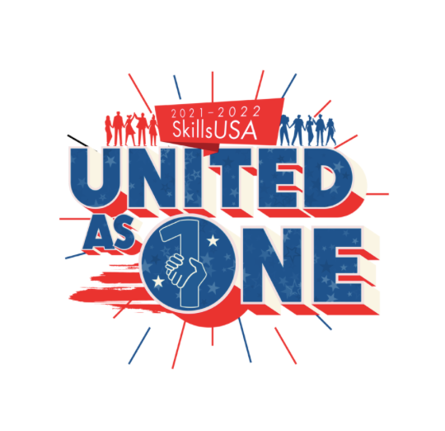
The SkillsUSA competition theme for the 2021-2022 school year is SkillsUSA: United.

The topic to be addressed by contestants in 2021-2022 competitions is our theme, “SkillsUSA: United as One.”

With this topic, contestants might illustrate or discuss any of the following:
- What does “United as One” mean to you in relation to your SkillsUSA chapter?
- How has your participation in SkillsUSA made you a better team member and what have you learned and demonstrated around the Essential Element of teamwork?
- How has your participation in SkillsUSA impacted your knowledge and demonstration of the Essential Element of multicultural sensitivity and awareness?
- How is the theme, “SkillsUSA: United as One” related to the SkillsUSA Framework and how will the Framework, in turn, prepare you for career success?
- What activities or learning within your career and technical education program haave prepared you to contribute to a business setting with the attitude of “United as One?”

SkillsUSA Georgia Region Championship
Eligibility Verification Form

School: _________________________________________________________

Advisor: ________________________________________________________

I verify that each student entering the Region Competition in the 2021-2022 SkillsUSA Georgia Championships is a SkillsUSA member listed on the online membership roster at least one day prior to the Region Competition. I also verify that, to the best of my knowledge, each student is eligible within the guidelines set forth in the 2021-2022 SkillsUSA Championships Technical Standards.

___________________________________ _______________________

Advisor’s Signature Date

Verification of

Online Roster Submission

I verify that a check has been requested and cut for payment of the Online Membership Roster of the local SkillsUSA chapter. The check was cut on _________________in the amount of _______________.

__________________________________ _________________

Advisor’s Signature Date

OR

I verify that a check has been requested and Purchase Order processed for payment of the Online Membership Roster of the local SkillsUSA chapter. The Purchase Order was processed on ___________________(date) in the amount of _________________.

Bookkeeper Signature

SkillsUSA Georgia Code of Behavior

- Teachers/advisors will assume full responsibility that delegates always abide by the SkillsUSA Georgia dress code and code of behavior including travel to and from conference.
- Participants shall be prompt and prepared for all activities. All delegates shall behave in a courteous manner and refrain from language and/or actions that could bring discredit upon them, their school and/or SkillsUSA Georgia. Delegates should always wear name badges.
- Delegates agree not to consume or have in possession any alcoholic beverages or non-prescription narcotics, gamble, smoke or use other tobacco products during the conference.
- Conduct not conducive to an educational conference will not be tolerated. Examples of unacceptable conduct include, but are not limited to, disrupting a businesslike atmosphere, consorting with non-conference individuals or any activities which will endanger self or others.
- Delegates are expected to attend all general sessions. Delegates shall keep their advisors always informed of their activities and whereabouts.
- Delegates shall refrain from all types of roughhousing.
- Delegates shall respect the property of which they are a guest and will pay for any property damage or loss that occurs due to their attendance during the conference.
- Delegates shall not use portable stereos or other loud music making devices.
- Participants violating any of the rules of conduct will subject their entire delegation to be unseated.
- Participants may be sent home at their own expense for violating any of these rules of conduct. Violators (and their chapter) may be suspended for one year.

It is hoped that each student attending the conference will take this Code of Behavior with a positive attitude so that SkillsUSA Georgia will continue to have the respect of education, businesspeople, and the public.

Student’s Signature____________________________________School_________________________

I have read and understand the Code of Behavior. I have informed my son/daughter of the importance of his/her conforming to its provisions.

Parent’s Signature____________________________________ Date __________________________

I have read and understand the Code of Behavior. I have informed my students of the importance of his/her conforming to its provisions. I have reminded them also that an infraction will be reported to me by the State Director who has the authority to take prudent disciplinary action as he or she sees fit.

Principal’s Signature_____________________________________Date_________________________

I have read and understand the Code of Behavior. I have instructed my students of the importance of his/her conforming to its provisions. I understand that I am responsible for said student’s actions while participating at the conference.

Advisor’s Signature______________________________________Date_________________________

Personal Liability / Medical Release / Photograph Release

All children, students, and adults who attend any SkillsUSA Georgia Conference require this form. No conference attendee is allowed to participate unless SkillsUSA Georgia receives this form. Parents and chapter advisors: Please make a copy of this completed form for your records. First, each student must complete the local school system medical release form. This form should be kept by the local chapter advisor and follow local school system policy.

Name___________________________________ Telephone__________________________

Home Street Address_______________________________ City/State/Zip _________________________
Advisor_______________________________ School _________________________________________
Advisor Cellphone Number (for emergency use only) _____________________________________

At Home Emergency Contact: __________________________ Phone number: _________________________
“I hereby agree to release SkillsUSA Georgia, its representatives, agents, servants and employees from liability for any injury to above named person at any time while attending the SkillsUSA Georgia State Leadership and Skills Conference, including travel to and from the conference, excepting only such injury or damage resulting from willful acts of such representatives, agents, servants, and employees.”
“I do voluntarily authorize SkillsUSA Georgia local chapter advisors, state advisor, state director, assistants and/or designees to administer and/or obtain routine or emergency medical treatment for the above-named person as deemed necessary in medical judgment.”
“I agree to indemnify and hold harmless National SkillsUSA, SkillsUSA Georgia and/or assistants and designees for any and all claims, demands, actions, rights of action, or judgments by or on behalf of the above-named person arising from or on account of said procedures or treatment rendered in good faith and according to accepted medical standards.”
“I hereby authorize any physician member of the Department of Emergency Medicine of an accredited hospital or any member of the medical staff of an accredited hospital to render medical treatment, which in his/her judgment is deemed necessary in the care of the above-named person (child or student) while attending the SkillsUSA Georgia activity, including time traveling to and from the conference.”
“I permit SkillsUSA Georgia to use video footage and photographs of my child for publicity that might include but is not limited to website, PowerPoint presentations, promotional videos, flyers or news publications.”

Signature of parent or guardian (if child or student) Date

Participant's or advisor’s signature Date
A COPY OF THIS FORM MUST BE KEPT BY THE STATE AND CHAPTER ADVISORS AT THE CONFERENCE AND GIVEN TO APPROPRIATE MEDICAL AUTHORITIES IN THE EVENT OF A MEDICAL EMERGENCY.

Region Championship Registration Directions
Instructions:
1. Please log on to: www.skillsusa-register.org to register your chapter for your region competition.
2. You will enter your email address and the password that you created when you submitted your online membership. If you did not previously create a password, then you can proceed to do that on the site by following the instructions listed.
3. After you have logged in, click on the “Conference” tab at the top of the page and then the drop-down box of “My Registrations”.
- Be sure to select the correct REGION CONTEST from the “Filter Event” drop down box.
- Then click “New Registrant”. For each contestant, click on the “Contest” tab at the bottom of the page to enter the correct contest. You do not need to complete the “Emergency” tab since each participant will complete the enclosed form titled: Personal Liability / Medical Release / Photography Release.
4. You will continue to add new registrants and save them until everyone from your chapter has been registered.
5. PLEASE ensure the following:
a. Each attendee’s name is spelled correctly
b. The correct contest has been selected for each attendee
c. Each attendee is also a registered SkillsUSA member
6. Once you have completed registering all your attendees, you may print the fee summary and registration summary from the website (you can find these by going to the top of the webpage and holding your cursor over the heading titled Conferences – the fee summary and registration summary will appear in the drop-down box). SkillsUSA Georgia will send you an official invoice once your region registration has closed.
7. Payment for the conference should follow the submission of your online registration. Registration fees should be paid in full prior to the competition. Credit card payment may be made online using the Pay Now Link on the invoice. PLEASE NOTE: Payment is expected for any participant entered in the system at the close of registration.
8. The deadline for on-line registration is Friday, November 12th, 2021. Contestants that are not registered by this date will not be allowed to compete.
9. Absolutely no refunds will be granted after the registration deadline date.

Resume Tips for Region Championships

Objective: Write a professional resume to prepare for the Region Championships, State Leadership and Skills Conference, as well as college or a part-time job

Instructions: Use the following guidelines to write your resume. If you already have a resume, read through the guidelines and see if your resume could be adjusted to better highlight you as a student and potential employee. Remember that every Region and SLSC competitor will need to turn in a resume.
Heading
Your name, address, telephone number, and e-mail address should all go at the top of your resume. Be sure to use a permanent address and telephone number. Also, remember to use an e-mail address that sounds professional. Do not use an e-mail address such as hottie@gmail.com. It does not sound professional.

Objective
An objective lets college recruiters or potential employers know your main goal. If your target is a college recruiter, tailor your objective to that specific school. For example, your objective may be, "To earn a degree in Education at Georgia College and State University." If you want to get a part-time job, you will need to modify your objective to that job, such as "To obtain a part-time sales position with Kohls."

Education/Academics
In the education section, list the schools you have attended. Be sure to include your GPA if it is a 3.0 or higher. You can also mention any academic honors, awards, and/or recognitions that you have received. These can include honor roll recognitions, essay writing awards, science competitions, etc.

Experience
The experience section should briefly give an overview of work experience that has taught you valuable skills. In this section, include title of position, name of organization, location of work (town and state), dates of employment, and description of work responsibilities. Be sure to use action words to describe your job duties, such as sold, created, processed, etc. Since many high school students do not have a lot of work experience, you can also describe class projects in which you have learned important skills or even leave this section out all together and concentrate on the education/academics and additional information/extracurricular sections.

Additional Information/Extracurricular Activities
The additional information or extracurricular section should be used to place key elements of your background that don't fit in any other section. You may want to include special skills, leadership roles, volunteer experiences, participation in sports, band, yearbook, etc. This section is where you can demonstrate your uniqueness.

References
Be sure to ask people if they would serve as your reference before you give their names out. You do not need to include your reference information on your resume. A statement at the bottom of your resume that says, "References available upon request," is sufficient.

