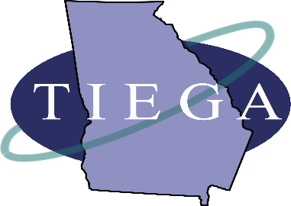
Trade & Industrial Educators of Georgia (TIEGA) is a professional organization for Georgia teachers, counselors, administrators and other professionals in the following career clusters:
- Architecture and Construction
- Arts, AV/Technology & Film
- Law & Public Safety
- Personal Care Services
- Transportation
TIEGA is committed to serving our members by providing quality professional development, training and teacher resources for our members throughout the year, including the TIEGA Winter Conference, Camp T&I and GACTE. Our newly revised website has links to some of the most helpful websites for teachers in your career clusters and pathways. Please visit our TIEGA website to learn more. https://tiega.org
If you have any questions, please feel free to contact us:
TIEGA President
Amanda Pugh
amanda.pugh@barrow.k12.ga.us

GA DOE Program Specialist
(Architecture and Construction; Arts, AV/Technology & Film; Transportation)
Tim Elliott
telliott@doe.k12.ga.us

GA DOE Program Specialist
(Law & Public Safety; Personal Care Service)
Sandra Martin
sandra.martin@doe.k12.ga.us

